ICCF AMICI – Issue 01
10.06.2004

PRESIDENT‘S COLUMN
by Josef Mrkvička, ICCF President

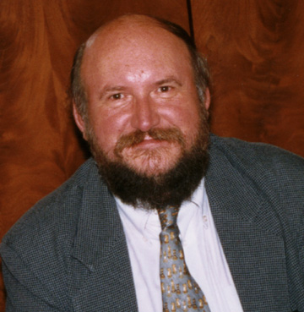

Dear readers, dear ICCF friends,

Welcome to my very first column in ICCF AMICI!

In this column, I will inform you regularly about the work which was done in the ICCF Executive Board in the period since the last ICCF AMICI issue.

Webserver Project

The Webserver Project approved at Congress in Ostrava is running in line with the agreed time schedule and budget for the year 2004. I am pleased to announce that in comparison with the time schedule, the developing work even could be accelerated, without any negative impact on the costs and quality.

The Steering Group has elaborated and approved the Functional System and Detailed Design of the ICCF Webserver. These documents are progressively updated, depending on the progress of the programming and testing work. Based on these fundamental documents, the developing work started in the end of 2003 and has progressed significantly. The Steering Group has already elaborated and signed off initial Webserver rules. A special test team of experienced ICCF players and International Arbiters, lead by Carlos Cranbourne (ARG) has been created; this team will test the particular system features before the system is released.

Furthermore, the Steering Group has progressed significantly in its discussions about the detailed Patron of ICCF programme (as in general approved in Ostrava) and about the structure of the ICCF Webserver tournaments in 2004. Special announcements about Patron of ICCF programme schemes are published at another place in this ICCF AMICI issue.

Zonal matters

On 1st January, 2004 the new elected Zonal Directors took over their positions and appointed their deputies as follows:

Zone 1 – Europe
Gian-Maria Tani (ITA) – deputised by Sergey Grodzensky (RUS)

Zone 2 – Latin America
Guillermo Toro Solís de Ovando (CHI) – deputised by Carlos Cranbourne (ARG)

Zone 3 – North America and Pacific
Ruth Ann Fay (USA) – deputised by Jason Bokar (USA)

Zone 4 – Africa / Asia
Mohamed Samraoui (ALG) – deputised by Dinand Knol (RSA)

As you know, the ICCF Congress in Ostrava decided that effective from 1st January, 2004 the European Zone should have its own administration, tournament office and financial management, as the other Zones have.

The reports of new Zonal Director of the Zone 1, Gian-Maria Tani show that this task has been pushed ahead successfully. Today, the decisive positions in the new European Executive Committee have already been covered, including the Tournament Office for European title and promotion tournaments.

In the Zone 4, Indonesia was recruited as a new member federation and granted a provisional ICCF membership according to the ICCF Statutes. The new membership should be confirmed by the ICCF Congress in Mumbai.

Vacant position in the Management Committee

Unfortunately, and despite all our efforts, the important position of the Marketing & Public Relations Commissioner still remains vacant.
The principal task of this new ICCF Senior Officer should be to develop marketing documentation on ICCF tournaments and services for use by the Deputy President & Development Director, Webmaster and media outlets both via WWW and printed material, co-ordinating appropriately with other ICCF officials – in other words, to provide an administrative “marketing support“ to the Deputy President & Development Director.
Furthermore, in consultation with the Deputy President & Development Director, he should produce attractive and informative material for use in the encouragement of potential new member federations and for the attraction of new sponsors of ICCF. Finally, he should be responsible for the production and editing of the ICCF Telechess Articles for the ChessBase Magazine.
On behalf of the Executive Board, I ask kindly all national Delegates to help us to find an appropriate person who would be able and willing to perform this work. The proposals should be sent to the Deputy President & Development Director, Max Zavanelli (USA) DeputyPresMax@aol.com.

Other personal and organisational matters

Shortly after Congress in Ostrava, the following ICCF Commissioners were appointed:

Rules Commissioner: Gerhard Radosztics (AUT) – deputised by Per Söderberg (SWE).

Non-Title Tournaments Commissioner: Valer-Eugen Demian (CAN) – deputised by Daniel Finkelstein.

The Qualifications Commissioner Eric Ruch (FRA) appointed Frank Geider (FRA) as his deputy. The Title Tournaments Commissioner Søren Peschardt (DEN) appointed Kristian Rohde Jensen (DEN) as his deputy.

For personal reasons, the ICCF Title Tournaments Commissioner Søren Peschardt (DEN) recently retired. In March, 2004 the Executive Board promoted Daniel Finkelstein to this important position. Therefore, Daniel will have to be replaced as the deputy of the Non-Title Tournaments Commissioner. For a new update of the Table of Qualifiers, a small working group chaired by Peter Coleman (ENG) has been established.

Witold Bielecki (POL) was appointed as Chairman of the Tournament Rules Commission.

Furthermore, the Executive Board appointed Ivan Bottlik (HUN) as Chairman of the Historical Research Committee. Ivan will develop the work programme and recruit members for this new Committee. The first project should be a compilation of the bibliography of CC (from all over the world) – a complete list of books and periodicals.

ICCF Statutes

The President’s Commission has started its work at the new ICCF Statutes which should be presented to the ICCF Congress in Mumbai 2004 for its approval.

The areas to be discussed are:
- legal status of ICCF, including its official seat,
- membership matters,
- range of titles awarded by ICCF,
- relations between ICCF and external CC organizations (IECG, IECC, CiF etc.),
- relations between ICCF and its sponsors,
- structure of ICCF, particularly division in Zones,
- ICCF Congresses,
- marketing functions and the promotion of ICCF,
- people issues.

As a fundamental document for this discussion, the paper “ICCF and its Future” presented by Nol van’ t Riet (NED) at Ostrava Congress was accepted.

Review of the ICCF Playing Rules

The Playing Rules Commission is about to finalise the review of the postal Playing Rules and is still discussing the Email Playing Rules, with the “phoney day” being still one of the main issues discussed within the Email play area.

Two new members, Josep Mercadal Benejam (ESP) and Ken Reinhart (USA) were added to the Playing Rules Commission.

Marketing

The Deputy President & Development Director, Max Zavanelli (USA) edited and distributed within the NAPZ a two-page informative brochure about ICCF (in PDF format). This brochure has been edited in all official ICCF languages – English, German, Spanish, French and Russian. The postage for postal distribution within the NAPZ was covered by the US national federation. Our grateful thanks to Max for this useful achievement in the marketing area.

A copy of this brochure can be claimed by Max and / or by all Executive Board members. Also, this brochure will be downloadable from the ICCF website soon. We encourage all delegates to use it within their countries for a promotion of ICCF and for recruiting new players for ICCF tournaments.

Analysis Prize Competition – New In Chess
Long ago, the participants in the 3/4-Final of the 1st Email Chess World Championship, sponsored by NIC (3/4-Final 20) and in the Semifinal of the 2nd Email Chess World Championship, sponsored by NIC (Semifinal 25) were encouraged to submit their annotated games for this competition to the ICCF Honorary President Alan Borwell (SCO). The official deadline will be within one month after the closing dates for both tournaments.
Although both tournaments have not yet been finished, the number of submissions for this competition has not been satisfactory.
Therefore, I ask all Tournament Directors in these events to encourage players to submit their annotated games for the competition. Our sponsor NIC provided us very nice prize money for that, and it would be pity not to take advantage of this opportunity. Furthermore, the delivery of annotated games is one of the ICCF commitments resulting from the sponsorship agreement with NIC.

Correspondence Chess Players Photo Album
Our Italian friends ASIGC created a very nice website with photos / short bios of correspondence chess players, which has been placed on the website of the European Zone on:
http://www.iccf-europa.com/foto/album.html

I recommend you all to visit this site and to help our Italian friends to enlarge this nice collection of photos – the ASIGC webmaster Maurizio Sampieri msampieri@iol.it would surely be grateful for any addition to his collection.

ICCF Congress 2004 in Mumbai
Our Indian friends from AICCF work hard on the Congress arrangements, strongly supported by the Zonal Director Africa / Asia Med Samraoui (ALG).
The preliminary budget and outline programme of the Congress have already been submitted by AICCF. On 13-14th March, 2004 I visited Germany and discussed the Congress arrangements in detail with Dr Ambar Chatterjee (IND) and Med Samraoui, with the aim to distribute invitational papers by end April.

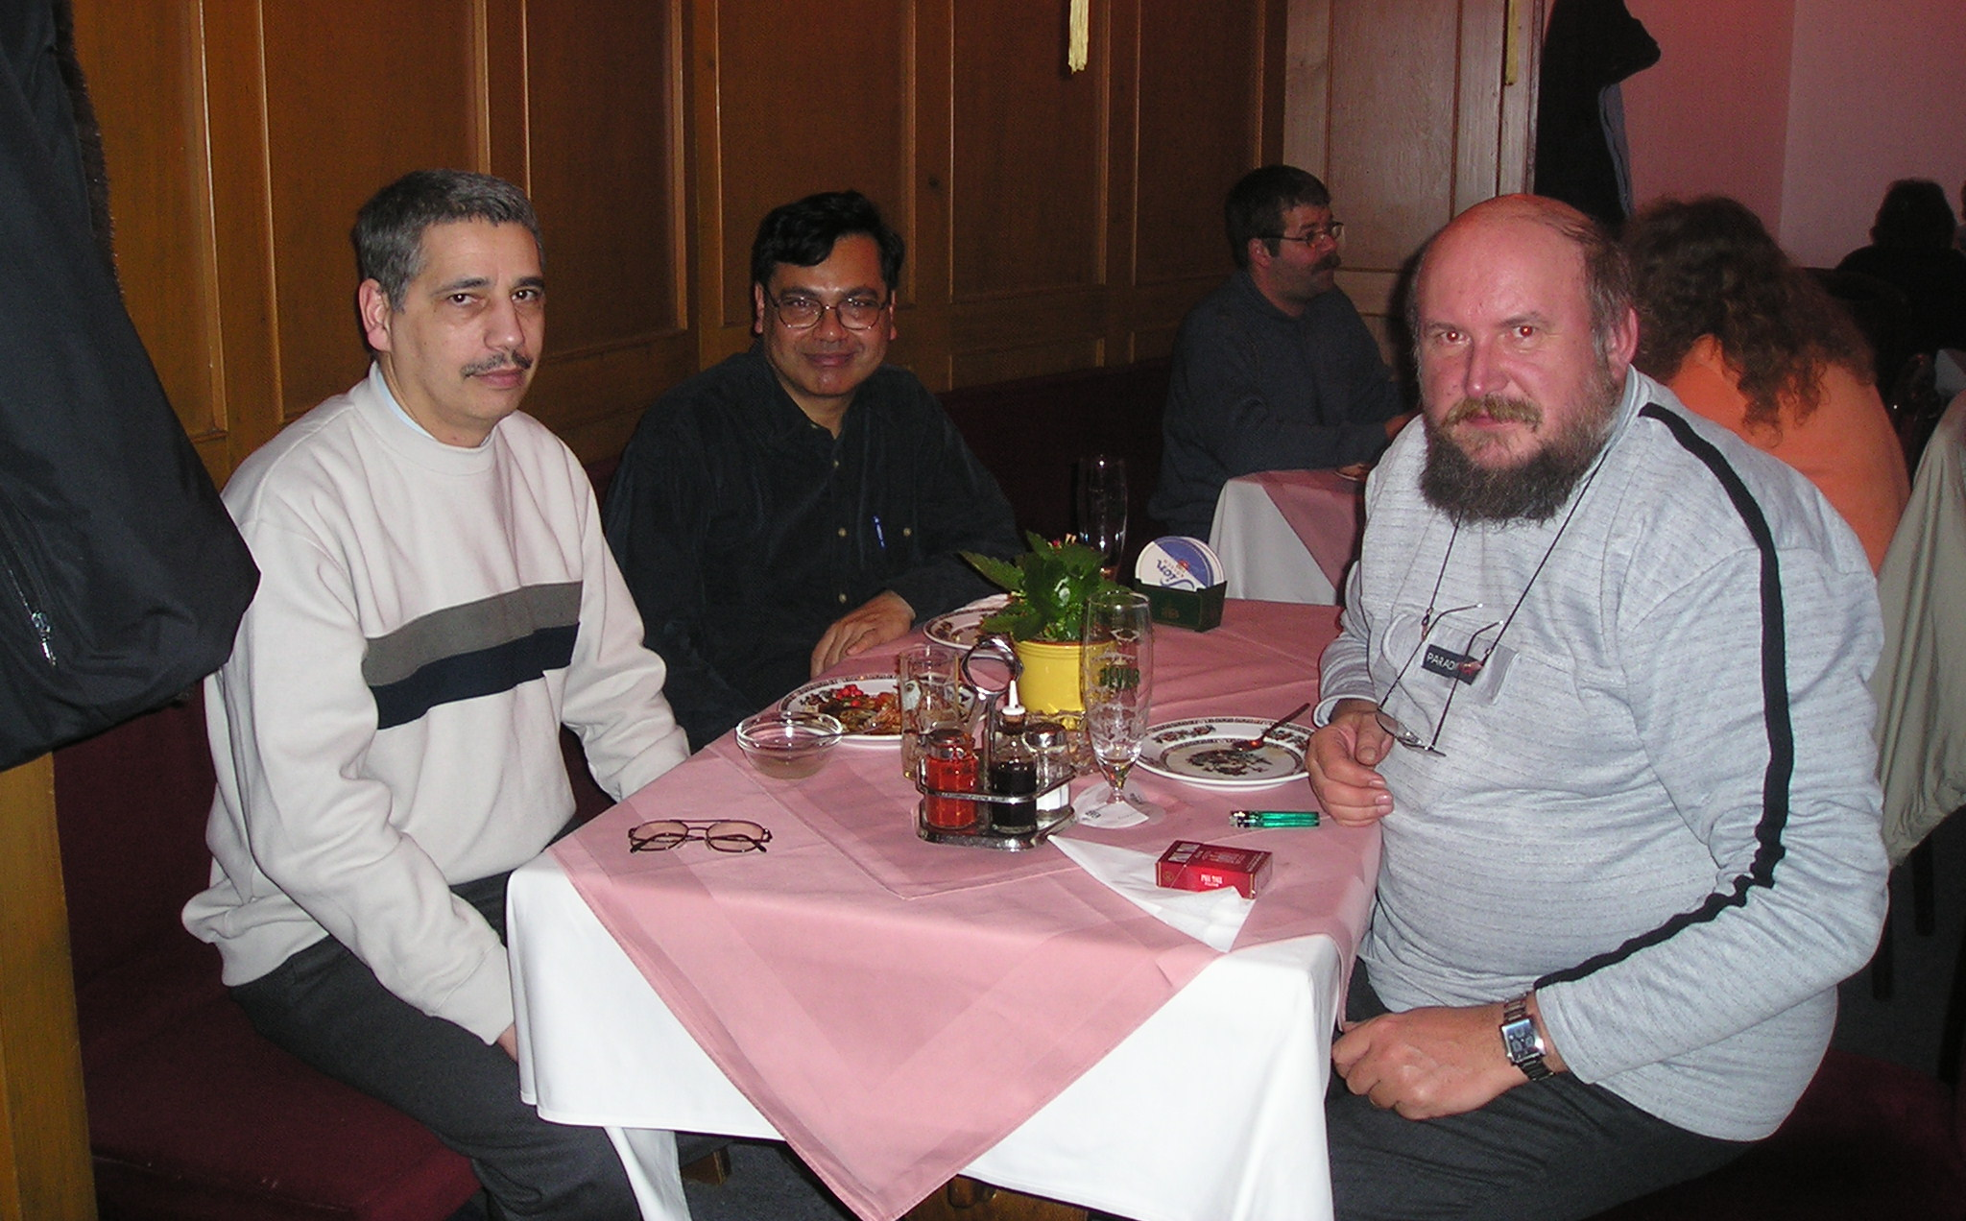

Working dinner in Jülich: Med Samraoui, Ambar Chatterjee and Josef Mrkvička

Based on the results of the preliminary questionnaire, approx. 60 participants from abroad are expected to attend to Mumbai Congress.

The following outline programme of Congress was approved:

Saturday October 30th, 2004 - arrivals & welcoming banquet
Sunday October 31st – opening & first day session & opening banquet
Monday November 1st – second day session, ladies programme &
simultaneous play
Tuesday November 2nd – third day session, ladies programme & match
against local club
Wednesday November 3rd – fourth day session, ladies programme & evening
free for EB or other meetings
Thursday November 4th – a full-day excursion covered by AICCF & blitz
tournament
Friday November 5th – a day free (or an optional excursion) & closing
banquet
Saturday November 6th – departures or start of the Golden Triangle Tour

Negotiations with ChessBase GmbH in Hamburg

On 27th February, I visited the seat of the company ChessBase in Hamburg and discussed with Mr Matthias Wüllenweber the future co-operation between ICCF and ChessBase.

During these negotiations, I informed ChessBase about the ICCF development after Ostrava Congress and about the most important tasks for ICCF to resolve before and at the Mumbai Congress (Webserver Project, new ICCF Statutes, new ICCF integrated tournament structure).

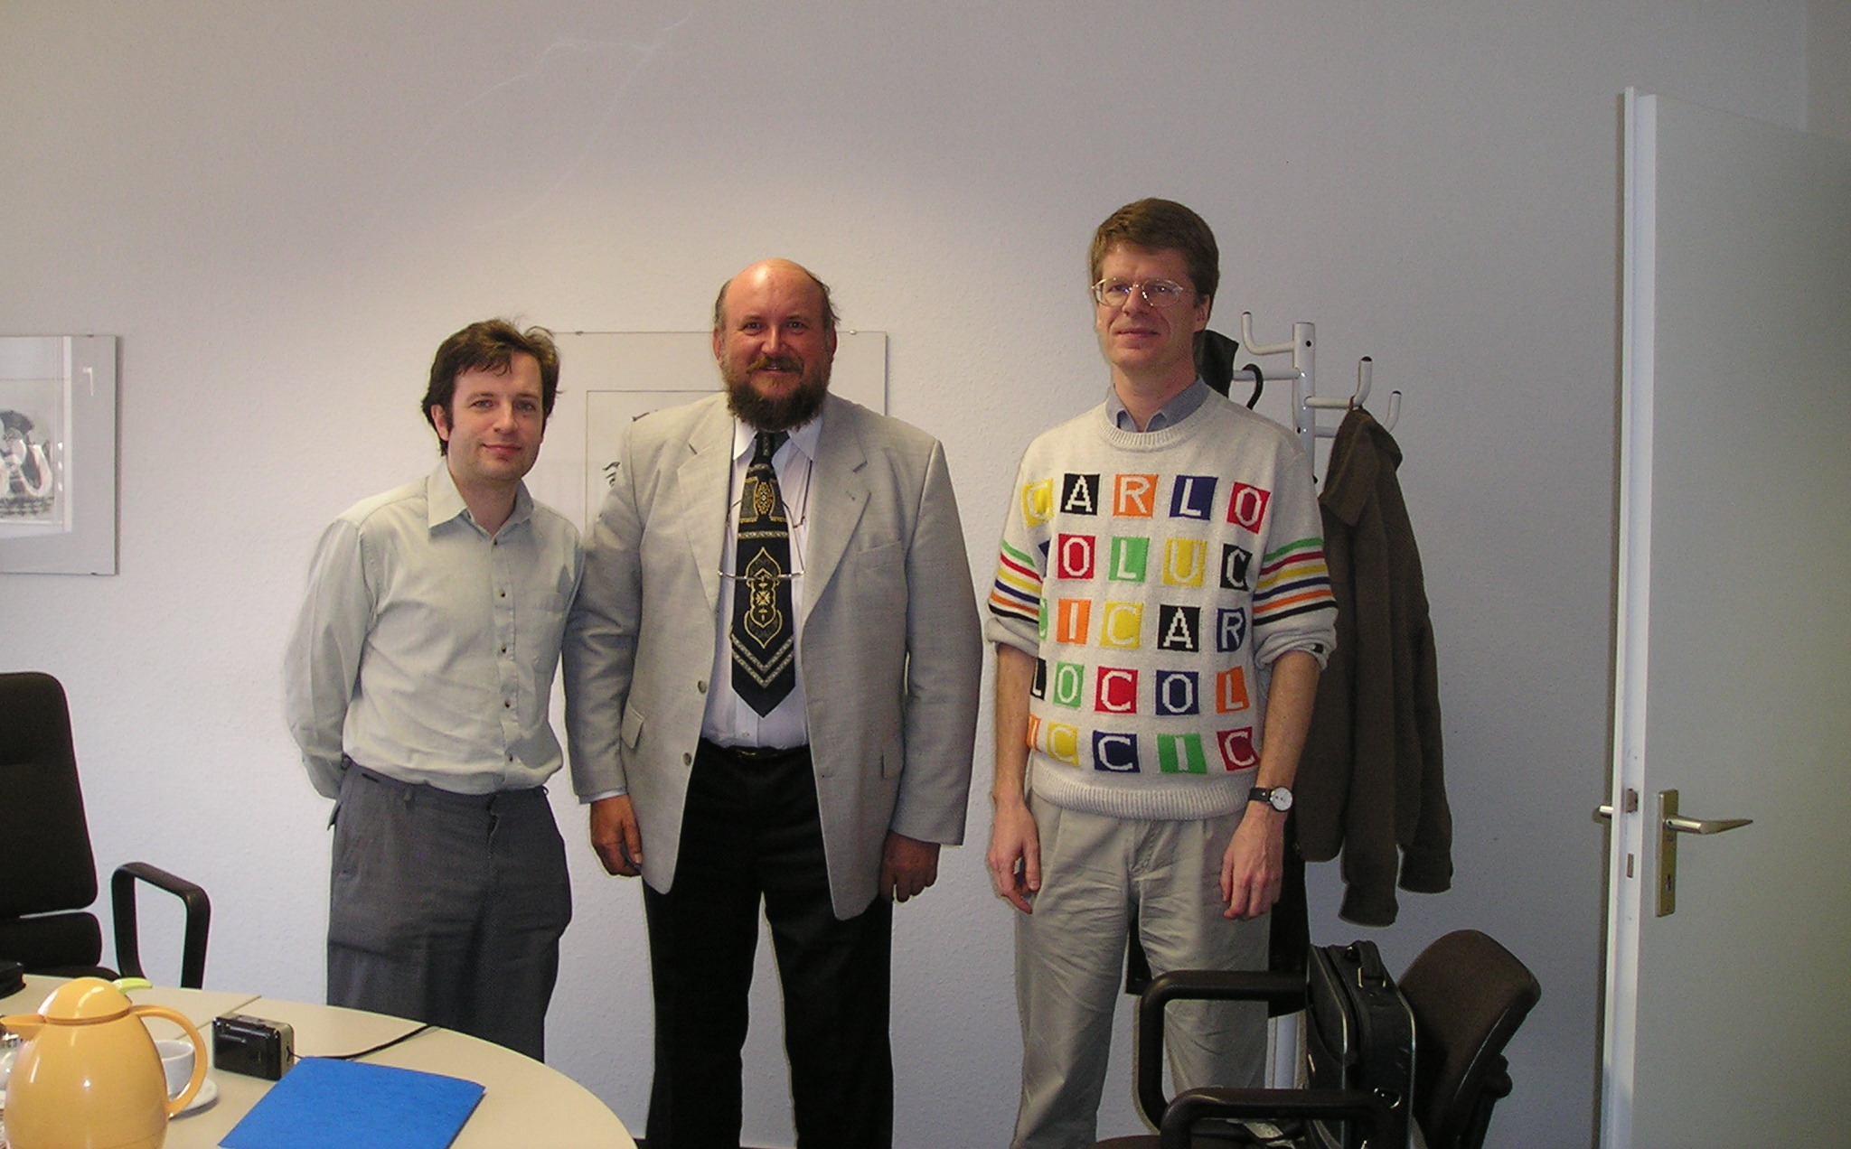

Martin Bennedik, Josef Mrkvička and Matthias Wüllenweber at ChessBase in Hamburg

Both sides stressed their permanent interest in a future close co-operation. In particular, ChessBase emphasised that they preferred to co-operate with worldwide acknowledged official chess organisations, like FIDE and ICCF.

ChessBase is ready to continue sponsoring future ICCF tournaments, preferably with book / software prizes. The detailed arrangements are to be designated for particular tournaments.

Martin Bennedik made a short presentation of the present status of the ICCF Webserver Project, which was highly acknowledged and appreciated by ChessBase.

From November 2004, ICCF proposed to ChessBase to provide their ICCF Telechess Articles for every issue of the ChessBase Magazine (bi-monthly). This proposal was thankfully accepted by ChessBase.

I asked ChessBase to make sure that no reference to ICCF events / tournaments will be made in the CBM articles presented by other CC organisations than ICCF. Mr Wüllenweber promised to forward this request to Rainer Knaak and other ChessBase people responsible for the CBM. I also emphasised that ICCF didn't consider it as correct that the articles in CBM are used for free promotion of commercial projects.

Finally, I gave an interview for the Radio ChessBase.

Negotiations with the Slovak CC Federation in Piestany

On invitation of the Slovak CC Federation, I visited Slovakia and as a special guest, I took part at the regular meeting of their Council held from 19 till 20 March, 2004 in POPPY Hotel in Piestany.

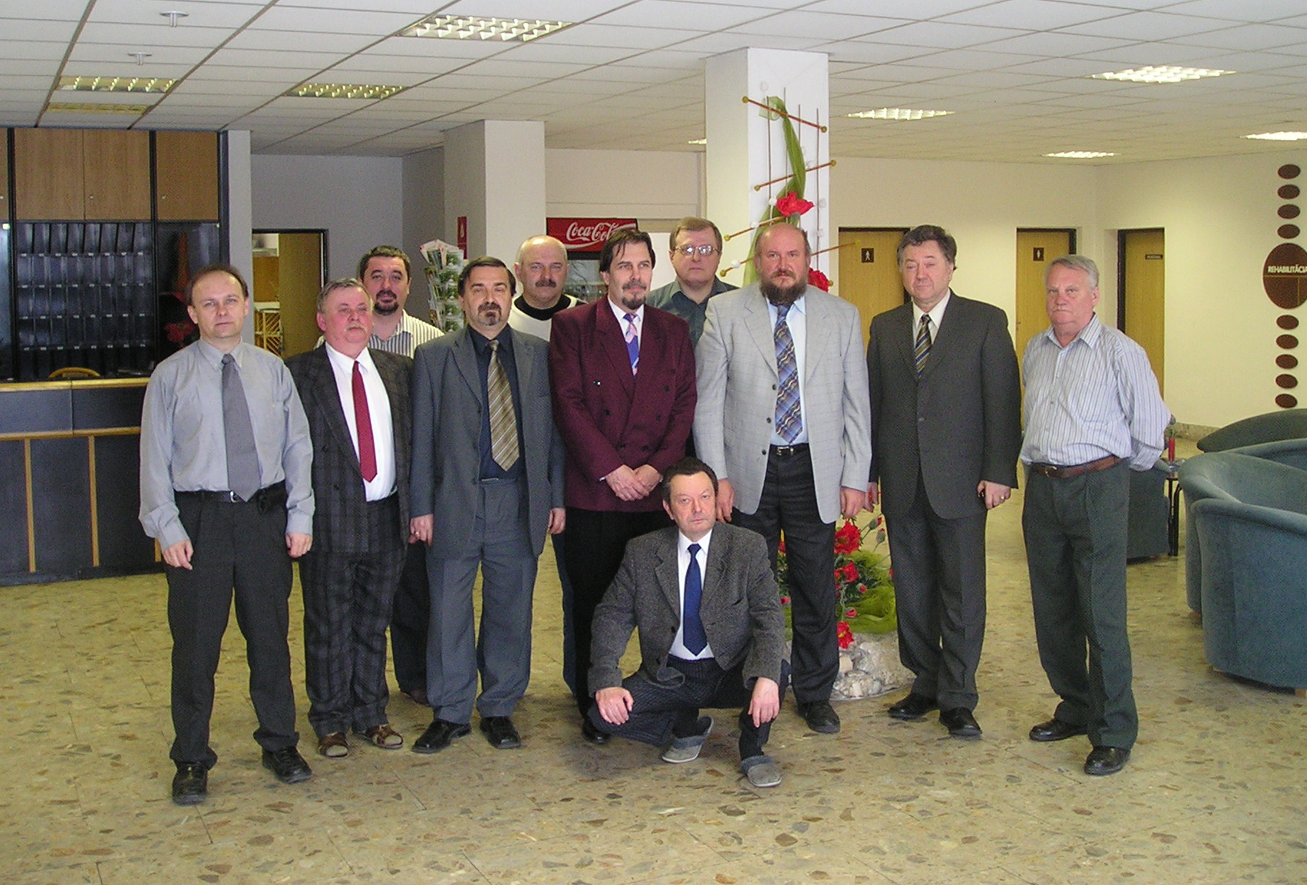

From left: Július Gajarský, Matej Botta, Peter Eiben, Milan Manduch, Stanislav Škerlík, Pavol Veselý, Juraj Václav, Josef Mrkvička, Pavol Polakovič, Peter Marczell, sitting Martin Kevický

On 20 March, I held a 2+ hours address to the Council members. I focused on and explained the new organisational structure of ICCF after Ostrava Congress, on the ICCF Webserver Project and on the principal ICCF tasks before the Mumbai Congress. After my presentation, I replied to some questions and gave a short interview to SIM Peter Marczell, editor of the Slovak CC Magazine.

In my address to the Council, I stressed that the Slovak players / officials should be more involved into the ICCF work. Slovakia is not represented at all in the current structure of ICCF bodies and Commissions, while there are some experienced players / officials who surely would be able to cover tasks on the international level.

Results:
- As the winner of the 1st Slav Cup team tournament, Slovak CC Federation will organise the second Slav Cup which should start in 2004 or early 2005. The exact start date to be agreed with the WTD. As in the first tournament, only teams from Slav countries will be eligible to participate.
- Slovak CC Federation will consider the organisation of the ICCF World Cup XV to be started in 2006.
- At the Assembly of Delegates in May 2004, the Council will address the present delegates, with the aim to recruit volunteers for the work in the ICCF Commissions and other ICCF working teams.

Negotiations with AJEC people in Paris

During our short holidays in Paris, my wife Alena and I were invited to a dinner by AJEC which took place on 27th March, 2004 in the restaurant Thoumieux. The AJEC President Olivier Bouverot, ICCF Delegate Eric Ruch and Pierre Ruiz Vidal participated on AJEC side.

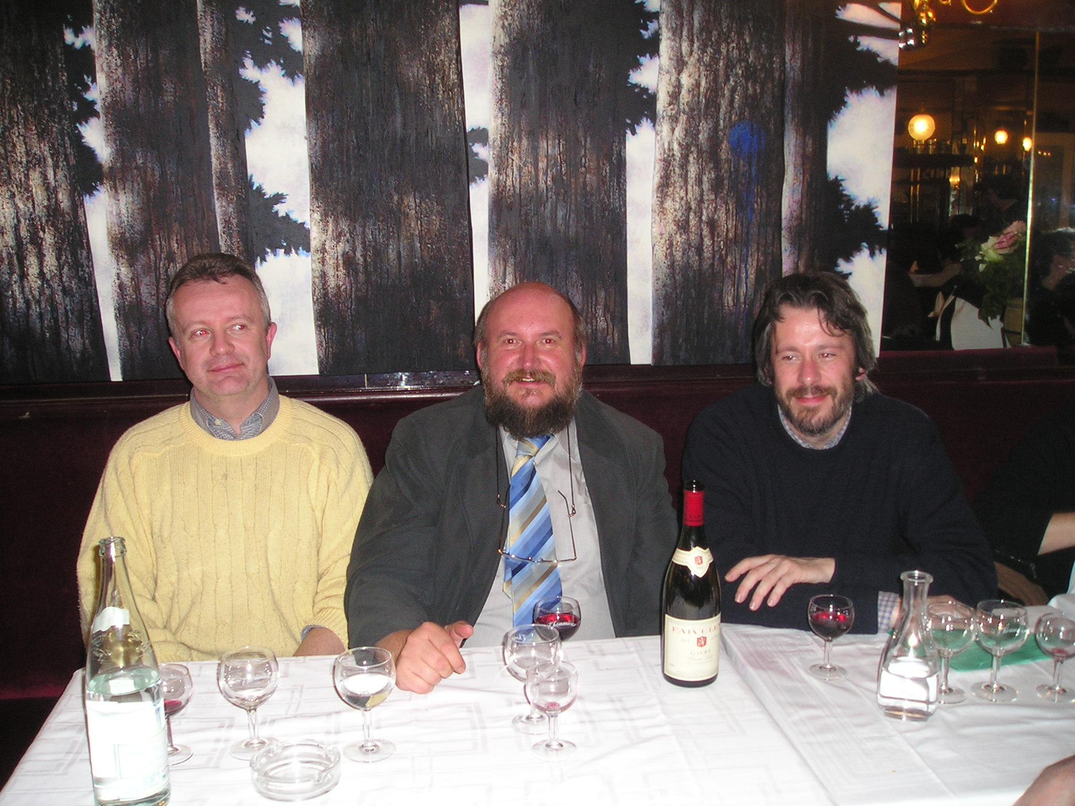

Eric Ruch, Josef Mrkvička and Olivier Bouverot enjoying the dinner in the restaurant Thoumieux in Paris

Just before my arrival, I gave an interview to Eric Ruch which would be published (in French) on the AJEC website and in "Courrier d'Échecs".

Actually, we didn't "work" too much during the dinner, but nevertheless, we discussed some ICCF issues, particularly the planned ICCF Congress 2007 in France.

POINT OF VIEW
By Alex Dunne

Welcome to the first issue of ICCF Amici, an ezine dedicated to international correspondence chess, and especially correspondence chess played under the aegis of the International Correspondence Chess Federation. I hope that this ezine can grow from its rather modest beginning to a more robust and informative force. What is needed now more than anything else is contributors. If you have games, especially annotated games, or are a chess writer who wopuld like to contribute articles of historical interest, I would certainly like to hear from you.
ICCF Amici would also like to establish some regular columns of interest to readers If you have some concrete ideas, contact me at alex.dunne@cqservices.com

What ICCF Amici would like to see are letters to the editor on all aspects of correspondence chess; annotated games, especially at the master level; ICCF tournament results; historical articles on correspondence chess; opening theory; articles that discuss the differences between email and postal chess; computers and correspondence chess, articles on how to use computers to improve correspondence chess; game collections for downloading; spotlights on ICCF personages, interviews and columns describing ICCF officials; spotlights on correspondence players; a column on the interpretation and implementation of the rules.

Together we can make a magazine. Come join us.

PATRON OF ICCF PROGRAMME

by Josef Mrkvička, ICCF President and
Chairman of the Webserver Steering Group

The 2003 ICCF Congress in Ostrava, approved the establishment of a new Development Fund and designated that the first development project would be the ICCF Webserver. Congress also unanimously approved the introduction of individual, group and/or national federation patronage of ICCF, with specific benefits, as one source of funding and it directed the Webserver Steering Group to make detailed arrangements to initiate and progress such funding.

The ICCF Webserver Steering Group and Executive Board have already announced the general outline of the programme, with specific details of two elements of the programme.

The purpose of the Patron of ICCF programme is threefold:

1. Provide a significant initial contribution to the ICCF Development Fund.
2. Provide an ongoing source of revenue for the ICCF Development Fund.
3. Provide a framework for future sponsorship arrangements between ICCF and individuals and/or organisations.

The Patron of ICCF programme will consist of three classifications, consisting of Individual, National Federation, and Corporate Patron of ICCF. Two specific benefits will be common to all patrons. Each classification of patron will have free use of a "Patron of ICCF" logo on their personal/organisation material and websites and will receive prominent recognition on the ICCF website and in other official publications.

The first designation of patronage will be the Individual Patron of ICCF. The minimum contribution for this designation will be CHF 500. This patronage will be considered to be for the lifetime of the patron. The name of each patron will be displayed on the square of his/her choice, on a 64 square chessboard, which will be prominently featured on the ICCF Webserver. If patrons prefer, they may, of course, remain anonymous.

Squares on the chessboard will be allocated based on the order of requests received by the contact person. When reserving your square please provide at least three alternative squares you would be willing to accept. Once a request has been acknowledged, arrangements will be made for payment of the contribution. Upon receipt of payment, the square will be guaranteed for that specific patron.

The second designation of patronage will be the Corporate Patron of ICCF. The minimum contribution will be CHF 3000 and the duration of the patronage will be five years.

A Corporate Patron will be given priority use of the ICCF Webserver system (after ICCF and Member Federation events), for their promotional tournaments. Normally, the standard fee will apply for such events, but Corporate Patron will have a right to organise the equivalent of three Category XIV (or above) and three Category XIII (or below) events of not more than 15 players per tournament, without the payment of any handling fee. These "free" events should be started in the 5 year period.

The contact person for the Patron of ICCF programme will be ICCF Finance Director, Grayling Hill. You may contact him with any enquiries at the following Email address:

Gvhill@aol.com.

ANNOUNCEMENT
ICCF Webserver Steering Group

Progress report and Features of the new ICCF WebServer

The Steering Group is delighted to announce that at present, the programming of facilities required by the first event in July (as announced on the ICCF website on 24th May, 2004) is being completed. The test team will spend the next 6 weeks systematically testing everything that has been done so far.

The Steering Group has recently signed an agreement with a hosting service for the Webserver and has transferred to their service in June.

The very first event will be the Webserver Test Open, sponsored by Chess Mail magazine. It will consist of 13 or 15 sections with 7 players each, with the winner qualifying for a Final next year.
In addition to Chess Mail subscribers, ICCF has selected some players to participate in this event, with vacancies to be filled by volunteers who have responded to an announcement placed on the ICCF website on May 24. In total, 84 entries were received, most of which will have the unique chance to participate in this first ICCF Webserver event!

After the first event starts, the programming of team events will still have to be completed, which is the last part of phase 1 of the project.
That programming work is expected to finish in August, after which ICCF can offer all types of event.

Phase 2 of the project will start some time after August and will expand and enlarge on the existing structure and include new and more complex features.

The ICCF Webserver is a purpose-built system for correspondence chess players and administrators. It can organise individual and team events on an international, zonal, national, or special category basis.

Organisers and administrators can quickly and flexibly tailor any event to suit their needs. There is a wide variety of options, including time controls, pairing methods, viewing rules for finished/unfinished games, player substitutions, and so on.

ICCF titles norms and ratings are fully supported, and the Webserver will automate many results and grading functions now and in the future.

Extensive playing facilities are offered, with many options to help players organise their games, schedule their holidays and leaves, and enjoy secure communications.

The Webserver is not a chess-playing engine, and will not evaluate positions. It will not recognise infrequent situations such as threefold repetition or the 50-move rule. It will however allow a limited form of conditional moves in those events where conditionals are selected by the organisers.

Of interest to players is how the Webserver calculates time.
Correspondence chess will still count in days. There is a central clock in the system, which timestamps each move made. If a reply is made within 24 hours of this timestamp then zero days is counted. One day is counted for each complete or part 24-hour period thereafter. So, the “phoney” email day is removed. The Webserver design allows for the addition of other methods of time calculation in future, but this will be the initial and standard method.

Initially, the Webserver will allow players to download PGN versions of their games for storage and offline analysis. An important feature of the Webserver design is a new interface standard, which will allow the Webserver to link to other chess software that also uses the standard.
ChessBase has agreed to implement this feature in a future release of their database product and support the new standard thereafter.

(Prepared by Iain Mackintosh, ICCF Webserver Project Manager with editing assistance from Grayling Hill, ICCF Steering Group Chairman, Pedro F.
Hegoburu, and Josef Mrkvièka, ICCF President.)

Dreaming of Manchester!
by ICCF-IM Valer Eugen Demian

2001 was an unusual year for our society. It proved to be a turning point generations to come will remember for quite a few reasons. The correspondence chess community will also remember it as the year of the Rimini congress. Oh yes, Rimini! Who can forget that? Any report did not offer justice to the incredible experience our Italian friends offered us all. It was the congress when the ICCF Server project was launched, where Mr Shri H. J. Samtani (India) spoke so many times with wisdom, as well as when Chris Lueers (Germany) launched the ICCF Champions League. I remember like it was last week how excited people were to be part of such new concept of team play regardless of nationality; some teams were already assembling their line-ups before the congress was over!

The qualification season is coming to an end. Twenty something games deciding the last qualification spots are being adjudicated this summer, as we all get ready to move ahead to serious divisional competition this November 2004. All 22 qualified teams for division A have already confirmed their participation. It is going to be a tough battle there considering there will be one group left after the 2004-2006 season. Division B teams have confirmed their participation in an overwhelming number. Divisions C and D will also offer a good challenge for anyone.

Looking back at the season winding down it is hard to choose a defining moment; there have been so many! Allow me to do my subjective top 5 list as I recall them.

1. This is a competition reflecting the true spirit of "Amici Sumus" and it comes from the essence of assembling participating teams based on friendship and not national flags. Hope I am not in minority when I am pleased to see the multicultural spirit - backbone of our Canadian society - spread into the World of correspondence chess. Each one of us has something to offer, to bring their particularities into a reacher, friendlier family.

2. The World Wide Web is the virtual paper of the new century. ICCF-CL has also been touched by this angel. I can remember the pleasure of seeing its dedicated webpages prepared and updated like nothing else before by Klaus Wrba (Germany). The bar has been raised in ICCF from that time on.

3. The excitement of the league spread like wildfire on TCCMB and several websites accross the World. Let's not forget the gauntlet thrown down by team CC.COM with their website and logo. It was just a matter of time until others caught up with it. Franklin Campbell (USA) came with the idea of gathering all logos and website links; now this is the cement holding together and inspiring players all around our corrrespondence chess community.

4. Have you had your dose of trash-talk yet? It proved to be an attractive feature on TCCMB and some teams websites. It brought into the league a new dimension of competition, something not seen in other ICCF competitions. Of course some do not like it, so for them it came the "Fortune Teller" virtual crystal ball. Too bad we didn't have the manpower to keep it going more often.

5. Forget for a minute the pain of sending your intention to play for your national team, just to know XX GMs will anyway be selected before you. When was the last time you've been named team captain and could make decisions on behalf of your team? John Knudsen (USA) gave the league its first team/ player finder facility, one we now dream of improving to an interesting "player transfer" facility comparable with soccer, hockey, or basketball.

I am sure each one of you reading this has his own selection of top moments, as well as of low moments. Let's not go over there for now. If you have suggestions, critiques, or want to offer everyone something you would like to see, please don't be shy and let us know! Do not wait for others to do it for you, but do as those ones who made the league possible did.

I am going to stop now with a short summary of the most important achievements in the league during the qualifying season, achievements put together by Marius Ceteras (ROM). More details of these achievements can be found on TCCMB for now.

a) More than 50 ICCF title norms have been scored from LIM to GM.
b) A tournament performance rating of 2900 has been scored by Vladimir Napalkov (Chess Victory, Russia) in group 2, board 3.
c) The only 100% score 10/10 has been scored by the same Vladimir Napalkov (Chess Victory, Russia) to ensure a 5 point overall margin of victory for his team
d) Top 100 tournament performance rating does not go below 2474 and sees players of a wide spectrum of chess abilities who raised their playing level in the league.

Have I got you excited yet? Want to become the Manchester United of correspondence chess? There's only one thing you need to do: get into the league this fall! Registrations start July 1st, 2004.

Correspondence Chess Reminiscence

By Eric RUCH

The Italian Rules

The Italian rules date back to the end of the 15th century – mid 16th century when the centre of the chess world moves from Spain to Italy.
They differ from the modern chess rules by the “passar battaglia” and the free castling. The “passar battaglia” forbids to take a pawn en passant. The free castling allowed a player to directly move his king to h1 and his rook to e1 for instance when castling king side, or the king to a1/b1 and the rook to b1/c1/d1 when castling queenside.
These rules were in use in Italy up to the end of the 19th century and it is generally considered that it was the Third National Chess Tournament held in Milano in September 1881 that definitively imposed the use of the international rules in Italy.
Many correspondence games have been played during the 19th century according to the Italian rules.

The game Berlin – Hamburg has been historically the first correspondence chess game played according the Italian rules. It is rather surprising that two German clubs used these rules, but this was probably due to the influence of the Ponziani’s treatise translated by V. Mosler “Das Schachspiels nach dem Italienischen des Autore Modenese”, Coblence in 1822.

Berlin - Hamburg [C54]
corr, 1834

1.e4 e5 2.¤f3 ¤c6 3.¥c4 ¥c5 4.c3 ¤f6 5.d3 0-0
Hamburg used the free casting by playing the King on h8.

6.0-0
Berlin also used the free castling by playing his King on h1, although this will have no impact for the rest of the game
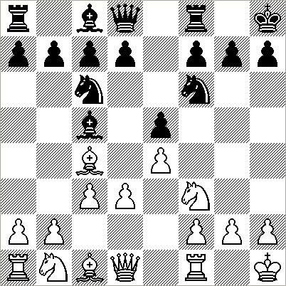

6...d6 7.£e2 £e7 8.¥e3 ¥xe3 9.fxe3 ¥e6 10.¤bd2 ¥xc4 11.¤xc4 ¦ae8 12.¤fd2 £e6 13.h3 g6 14.¦f3 ¤d8 15.¦af1 ¤d7 16.b3 c6 17.g4 ¢g7 18.¢h2 f6
and the game was agreed a draw in 83 moves. The free casting was not necessary and standard rules could have been applied.

The game played between Modena and Liverno, two italian cities, is much more interesting. I give here the annotations of Steinitz published in “the Fields” in 1879 and those of Count Cassoli one of the member of the Modena club published in the “Nuova Rivista degli Scacchi” in 1879.

Modena - Livorno [B22]
corr, 1877 - 1879

1.e4 c5 2.¤f3 e6 3.c3
The move 3.¤c3 followed by 4.d4 was suggested by Paulsen, and gives White a slight advantage. The text move is worth consideration because it eases white’s development.

3...¤c6 4.d4
4.¥b5 was perhaps stronger. 4...d5 (4...£b6 5.£e2 ¤f6 6.e5 followed by 7.0-0.) 5.¥xc6+ bxc6 6.£a4 ¥d7 7.d3 (7.¤e5 ¤f6 8.¤xc6? £b6) 7...c4 8.dxc4 dxe4 9.¤e5 with a good game.

4...d5 5.exd5 exd5 6.¥b5 £d6
The "Neueste Theorie" suggest 6...cxd4. This Queen move seems not necessary (F. Cassoli)

7.£e2+ ¥e7 8.dxc5 £xc5 9.0-0 -- 10.¦e1

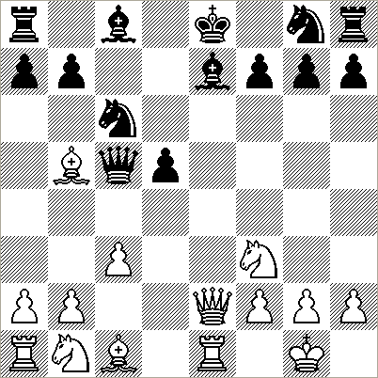

The free casting according to the Italian rules. According to most players, the possibility to move the Rook directly to e1 gives White a too big advantage
(RR to enter such a game into Chessbase, you have to enter a null move by pressing Ctrl Alt 0 and White is for instance allowed two moves at the same time. Of course the numbering of the moves is no more correct)

10...¥g4 11.¥e3
11.¥xc6+ was stronger, because after 11...bxc6 12.¥g5 Black had problems to castle.

11...¥xf3 12.¥xc5
12.¥xc6+ was still stronger. 12...bxc6 13.£xf3 £d6 14.¥d4 £g6 (14...f6 15.£g4 followed by b4.) 15.¤d2 followed by ¤b3 gives White the better game.

12...¥xe2 13.¦xe2 0-0-0 14.-- ¢b8
Again the free castling.

15.¥xe7 ¤gxe7 16.¤d2 a6 17.¥a4 ¢c7
It was necessary to bring the King in the center (Steinitz). A good move to support the isolated pawn (F. Cassoli)

18.¤f3 b5 19.¥b3 h6 20.¤e5
It was better to play before 20.a4 and if 20...f6 to prevent ¤e5, 21.axb5 axb5 22.¤d4 ¤xd4 23.¦xe7+ ¢d6 24.¦ae1 ¤c6

20...¤xe5 21.¦xe5 ¢d6 22.¦ae1 ¦d7 23.f4 g6 24.a4 ¦b8
The best move (F. Cassoli)

25.axb5 axb5 26.g4 ¦bb7 27.h4
27.¢g2 -- 28.¢f3 was better.

27...¢c6
Black has well played this difficult ending, but the text move loosed a tempo. (W. Steinitz).
It was better to play ¢c5 (F. Cassoli)

28.¢g2 ¢c5 29.¢f3 b4
Lose a pawn. 29...¤c6 was better 30.¦5e3 (30.¦e8 ¦e7 F. Cassoli.) 30...¤a5 followed by b4 or ¤c4.

30.¥a4 ¤c6
Risky. 30...¦dc7 was better.

31.cxb4+
Winning a pawn, but White king side remains weak and this neutralizes the material advantage.

31...¢d6
A very good move. 31...¦xb4? 32.¦c1+ lose a piece.

32.¥xc6 ¢xc6 33.¦c1+ ¢d6 34.¦c5 ¦xb4 35.¦cxd5+ ¢c6 36.¦c5+ ¢d6 37.¦b5
37.¦c2 followed by ¦5e2 to support the pawn provides no advantage (F. Cassoli)

37...¦b7 38.¦bd5+ ¢c6 39.¦d2 ¦b3+
Black’s defense is correct and White has to exchange a pair of Rooks. (W. Steinitz).
39...¦xb2 is a mistake 40.¦xb2 ¦xb2 41.¦e7 ¦b7 (41...¦b3+ 42.¢e4 ¦b4+ 43.¢e5 f6+ 44.¢xf6 ¦xf4+ 45.¢xg6 ¦xg4+ 46.¢h5 wins) 42.¦xb7 ¢xb7 43.¢e4 ¢c7 44.¢e5 ¢d7 45.¢f6 ¢e8 46.¢g7 h5 47.gxh5 gxh5 48.¢h6 and White wins (F. Cassoli).

40.¦e3
40.¢e4 ¦7b4+ 41.¦d4 ¦xb2 threatening ...¦e2+ hindering White to hold the strong square e7.

40...¦xe3+ 41.¢xe3 ¦b3+ 42.¢e4 ¦h3 43.¢e5 ¦xh4 44.¦g2 ¢d7 45.¢f6 h5
The best move.
45...¢e8 46.f5
A) 46...g5 47.¢g7;
B) 46...h5 47.fxg6 fxg6 (47...hxg4 48.¦e2+ wins.) 48.g5²;
C) 46...gxf5 47.gxf5

46.¢xf7 ¦xg4 47.¦c2 ¢d6 48.f5 gxf5 ½-½

Another interesting game has been played by Hamburg and Breslau (now Worclaw in Poland) in 1840.

Hambourg - Breslau (Worclaw) [C41]
Corr 1840
1.e4 e5 2.¤f3 d6 3.d4 £e7 4.¤c3 c6 5.h3 h6 6.¥c4 ¤f6 7.dxe5 dxe5 8.¥e3 b5 9.¥b3 a5 10.a4 b4 11.¤e2 ¥e6 12.¤g3 ¥xb3 13.cxb3 £e6 14.£c2 ¤fd7 15.0-0-0 -- 16.¢b1 -- 17.¦c1
White’s free castling.

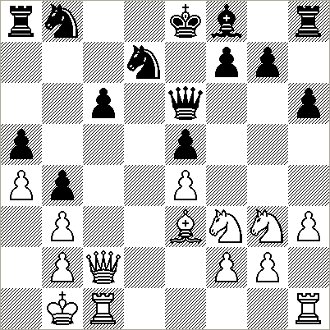

17...c5 18.¦hd1 g6 19.¦d5 ¤c6 20.¤e1 ¤d4 21.¥xd4 exd4 22.f4 £b6 23.¤d3 f6 24.f5 g5 25.e5 £b7 26.£c4 0-0-0 27.-- ¢b8 28.-- ¦c8
Black’s free castling.

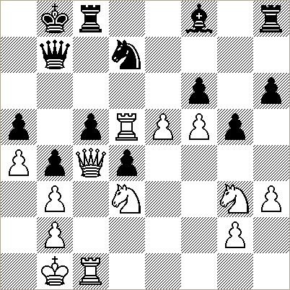

29.¦xd7 £xd7 30.exf6 £b7 31.¦e1 ¦h7 32.¦e6 ¦d7 33.¤e4 £d5 34.g4 £xc4 35.bxc4 b3 36.¤e5 ¦dd8 37.f7 ¢b7 38.¤f6 ¦c7 39.¤h7 ¦cc8 40.¤g6 ¦d7 41.¦e8 ¦xf7
The game was stopped in this position, but White should have a winning position after 42.¦xc8 ¢xc8 43.¤hxf8.

There are much less games where the “passar battaglia” rule had to be taken into account and the following one played in 1877 between the Ferrera and the Modena chess clubs is one of them:

Ferrara - Modena [C54]
corr, 1877
( Annotations by Comte Fernandino Cassoli)

1.e4 e5 2.¤f3 ¤c6 3.¥c4 ¥c5 4.c3 ¤f6 5.d3 d6 6.£e2 h6 7.¥e3 ¥b6 8.¤bd2 0-0 9.-- ¦e8
The free catling accoring to the Italian rules, but 8...£e7 was maybe better.

10.h3 ¤e7 11.g4 ¥xe3 12.£xe3 ¤g6 13.g5 ¤f4 14.0-0-0 -- 15.¢b1 -- 16.¢a1
Again the free castling.

16...hxg5 17.¤xg5 ¥e6 18.¥xe6 ¤xe6 19.¤xe6 ¦xe6 20.¦dg1 ¤h5 21.¤f1 £f6 22.¤g3 ¤xg3 23.¦xg3 £f4 24.¦hg1 g6 25.£xf4 exf4 26.¦f3 ¦d8! 27.¦xf4 d5 28.exd5 ¦xd5 29.d4 ¦g5 30.¦f1 ¢g7 31.a3 ¦g2 32.d5 ¦f6 33.¦b4 b6 34.¦c4 c5 35.b4
White cannot take en passant !

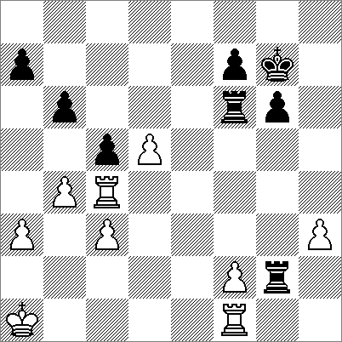

35...cxb4 36.axb4 ¦fxf2 37.¦xf2 ¦xf2 38.¦d4 ¢f8 39.c4 ¢e7 40.¢b1 ¦f3 41.¢c2?
Better was: 41.c5 bxc5 42.bxc5 ¦b3+ 43.¢c1 ¦b8=

41...¦xh3 42.c5 ¢d7 43.d6 ¦h8 44.¢c3
A draw was maybe still possible after 44.¦e4! bxc5! 45.bxc5 ¢c6 46.¦e7 ¢xc5 47.¦xf7 ¢xd6 48.¦f6+ ¢c5 49.¦xg6=

44...¢c6 45.¢c4 bxc5 46.b5+ ¢b6 47.¦e4 ¦h1 48.¦e3 ¦d1 49.¦d3 ¦xd3 50.¢xd3 ¢b7 0-1

THE AFRO-ASIAN CHAMPIONSHIPS STORY
M.Samraoui

During many years and till now , the postal service in Africa and in the large part of Asia was and is always the major handicap for correspondance chess development. The apparaisal of the electronical mail in the mid 90´s ( the fax was already out of fashion) and the advantages it offers , gives to CC a new era . The games become faster and cheaper . The duration of a tournament is reduced from 4-5 years (and sometimes more ) to less than 18 months . No more postcards lost during the transmission or waiting one or two months to receive the move.

1st email Afro-Asian championship 1998-2000

When the first zonal championship started in 1998 , it was really a curiosity , because it was the first internet´s steps in the most african countries , nevertheless 26 players from 17 differents countries applied and the competition started with 3 sections , the 3 top players will advance to the final.
In section A the favorite Khalid Chorfi , the IM from Morroco finished at 3rd place after suffering a loss to K. Ching from Malaysia who was unknown .
Ching won this section with 6,5 points/7 points, followed by H. Onoda from Japan 6 points and K. Chorfi 5,5 points. V. Pandit (IND) missed the qualification .
In section B , 3 players emerged S. Simonenko from Turkmenistan a FIDE IM with 7,5 points out 8, G. Altanoch from Mongolia with 7 points and Dr A. Chatterjee from India with 6,5 points
In section C Mekki Samraoui from Algeria was the winner with 7 points , followed by Namdeo from India and Tjiptadi from Indonesia both with 6,5 points.. R. Messerschmidt from South Africa was unlucky with 6 points and missed the final.

The final was dominated by the youngest player (13 years old) conceding only one draw to the experienced IM K. Chorfi (MRC) who finished unbeaten too. S. Simonenko not fortunate in this final , the single loss costed him the final victory . H. Onoda (JPN) took the 4th place with 5 points and G. Altanoch with 3,5 points. The deception came from K. Ching (MAS) and A. Chatterjee (IND) who did not play consequently .

1st EAAC 1998-2000 (26 players)
Mekki Samraoui (ALG) 7,5/8
Serguey Simonenko (TKM) 6,5/8
Khalid Chorfi (MRC) 6/8
Hirokaz Onoda (JPN) 5/8
Gendengin Altanoch (MGL) 3,5/8

One game played by the winner .

Mekki Samraoui (ALG) – G. Altanoch (MGL) , 1st email Afro-Asian ch, Final
1.e4 c6 2.d4 d5 3.Nc3 dxe4 4.Nxe4 Bf5 5.Ng3 Bg6 6.h4 h6 7.h5 Bh7 8.Nf3 Nf6 9.Bd3 Bxd3 10.Qxd3 e6 11.Bd2 Nbd7 12.O-O-O Be7 13.Ne4 Nxe4 14.Qxe4 Nf6 15.Qe2 Qd5 16.c4 Qe4 17.Be3 O-O 18.Ne5 Rac8 19.f3 Qh7 20.g4 Nd5 21.Bd2 b5 22.Ng6 !! fxg6 23.Qxe6+ Kh8 24.hxg6 Qg8 25.Qe5 Bf6 26.Bxh6! gxh6 27.Rxh7+ Kg7 28.Qh5 Rfd8 29.Rh7+ Kf8 30.Qf5 bxc4 31.g5 c3 32.gxf6 cxb2+ 33.Kxb2 Rb8+ 34.Ka1 1-0.

2nd email Afro-Asian championship 1999-2001

The success met by the 1st email championship is repeated one year later when 24 players from 12 different countries took part to the new battle for the title of Zonal champion.
In the preliminaries all the favorites achieved the qualification to the Final.
In section A , the title holder Mekki Samraoui is the runner up with 6 points behind K. Prabhakar from India who finished with 6,5 points . Akadegawa (Japan) hold the third qualificative place with 5 points.
In section B , N.R Anilkumar (India) and E. Hojdahl (Japan) were the best with 6 points and the IM K. Chorfi once again is third after losing his game vs Hojdahl and will qualify only thanks to the better SB. The unfortunate player was D.Dempster from Australia .
In section C , Paul Santhosh (India) made a perfect score , winning all his games , he was follwed by his countryman A. Chatterjee who finished with 5,5 points . The third place was shared by K.Tjiptadi from Indonesia and Kagiyama from Japan . Due to a lack of times Dr Chatterjee was not able to attend the Final , missing an absolut record of 4 indian players in the same Final .
The Final was very exciting with 4 candidates fighting for the victory and finally Anilkumar emerged as the new champion with 6,5 point . K. Chorfi followed him with 6 points and Mekki Samraoui took the third place with 5,5 points .
P. Santhosh , the star of the preliminaries met some difficulties during this Final and was not able to reach the podium . One year later he achieved the GM norm in the 1st ICCF email Olympiad . That is relevant for the quality of top zonal players .

2nd EAAC 1999-2001
N. Anilkumar (IND) 6,5/8
Khalid Chorfi (MRC) 6/8
Mekki Samraoui (ALG) 5,5/8
Erik Hojdahl (JPN) 5,5/8
Paul Santhosh (IND) 5/8

N. R Anilkumar (IND) – K. Johansson (SWE) : 1st email Olympiad
1.c4 e5 2.Nc3 Nf6 3.Nf3 Nc6 4.g3 d5 5.cxd5 Nxd5 6.Bg2 Nb6 7.a3 Be7 8.b4 Be6 9.Rb1 f6 10.00 00 11.d3 a5 12.b5 Nd4 13.Nd2 Bd5 14.Nxd5 Nxd5 15.Ne4 f5 16.e3 fxe4 17.exd4 exd4 18.Bb2 Nc3 19.Bxc3 dxc3 20.Bxe4 Qd4 21.Rc1 Bf6 22.Bxb7 Rad8 23.Be4 Qc5 24.Qb3+ Kh8 25.Kg2 Bd4 26.f4 Rb8 27.a4 c6 28.Qc4 cxb5 29.Qxc5 Bxc5 30.axb5 Bb4 31.Bc6 Rfd8 32.Rfd1 Rd4 33.Kf3 Rbd8 34.Be4 R4d6 35.d4 g6 36.Bc6 Rxd4 37.Rxd4 Rxd4 38.b6 Rc4 39.b7 Bd6 40.Bd5 Rc5 41.Ke4 Bb8 42.Kd4 Rc7 43.Rxc3 Rxc3 44.Kxc3 Kg7 45.Kc4 Kf6 46.Be4 a4 47.Kb4 a3 48.Kxa3 h6 49.Bxg6 Kxg6 50.Kb4 h5 51.Kc4 Kf6 52.Kd4 h4 53.Ke4 h3 54.Kf3 Kf5 55.g4+ Kf6 56.Kg3 Bd6 57.Kxh3 Bxf4 58.Kg2 Kg5 59.h3 Bb8 60.Kf3 Bc7 61.Ke4 Bb8 62.Kd5 Kf6 63.Kc6 Ke6 64.h4 1-0 .

3rd email Afro-Asian championship 2000-2002

Again 24 players from 10 countries have applied to this competition.
The winner and his runner up were the top favorites in section A , but surprisingly Anilkumar did not defend his title . His withdrawal let the competition very open and Ali Dikmen from Turkey won convaincly the section with 7 points . K. Chorfi , this time unbeaten , is qualified for the third time in row with D.Knol from South Africa ,both achieved 5 points . S.Terada (IM from Japan) missed the qualification with 4,5 points .
In section B two winners with 6 points and the same SB : L. Ball from South Africa and G. Altanoch from Mongolia . With 5 points Yamaguchi was the 3rd qualifier . I. Smuts (RSA) with 4,5 points and the former finalists Kagiyama (JPN) and Tjiptadi (INA) have not been able to jump to the Final.
The section C was won by Mekki Samraoui and Arif Kucukali from Turkey , both with 6 points , for the third qualificative place P.Kemp won the tie over his countryman S. Stone , both with 4,5 points . K. Benbachir with 4 points , missed again the qualification..

The final was played with 11 players , the IM/FIDE S. Simonenko (TKM) who finished second in the first edition and F. Balabaev (KAZ) who reached in 2002 an ICCF rating of 2661 have been invited by the zonal director to strenght this Final . Mekki Samraoui , who won the 1st zonal championship and the section C has choosen to play for Germany , he was replaced by S. Stone who finished 4th in the same section .

This Final was fantastic , with high level and interesting games . After more than one year of play A. Kucukali emerged unbeaten with 8 points , followed by D. Knol with 7 points who would regret his single loss to Kucukali . 3 players shared the “bronze” medal with 6,5 points S. Simonenko (TKM) , L. Ball (RSA) and P. Kemp (RSA) . A wonderful results for South African players who took , places 2, 4 and 5 in this very strong Final . The new ICCF GM F. Balabaev finished only at the 6th place with 5 points suffering 3 losses to Ball , Kucukali and Knol . 3 other players -K. Chorfi , A. Dikmen and G. Altanoch - shared places 7 to 9 with 4 points . Ali Dikmen made a bad tournament and was disturbed by a beautiful story : the birth of his child . He will take his revenge one year later .

The decisive game is :
A.Kucukali (TUR) – D. Knol (RSA) , 3rd email Afro-Asian championship Final
1.e4 c5 2.Nf3 d6 3.d4 cxd4 4.Nxd4 Nf6 5.Nc3 a6 6.Bg5 e6 7.f4 Qb6 8.Qd2 Qxb2 9.Rb1 Qa3 10.Bxf6 gxf6 11.Be2 Qa5 12.O-O Be7 13.Kh1 Nc6 14.Nxc6 bxc6 15.Bf3 Kf8 16.f5 h5 17.Rb3 exf5 18.exf5 d5 19.Qf4 Bd7 20.Na4 Bxf5 21.Nb6 Bxc2 22.Qc7 Kg7 23.Qxe7 Rae8 24.Qb4 Qxb4 25.Rxb4 a5 26.Rb2 Bd3 27.Rc1 Re6 28.Kg1 h4 29.Kf2 Rhe8 30.Nd7 Bc4 31.Rd2 Kg6 32.Nb6 Ba6 33.Rdc2 Bb7 34.Rc5 Ba6 35.Rxa5 Be2 36.Ra8 Rxa8 37.Nxa8 Bxf3 38.Kxf3 d4 39.a4 c5 40.Ra1 Re3+ 41.Kf4 c4 42.Nb6 c3 43.Nd5 1-0.

3rd EAAC 2000-2003
Arif Kucukali (TUR) 8/10
Dinand Knol (RSA) 7/10
Serguey Simonenko (TKM) 6,5/10
Laurence Ball (RSA) 6,5/10
Pietr Kemp (RSA) 6,5/10
Balabaev 5pts , Dikmen 4 pts, Chorfi 4pts

4th email Afro-Asian championship 2001-2003

With 39 players from 16 countries a new record is broken , and for the first time China is represented with 3 players . The same profil like in the previous preliminaries was adopted .
In section A , the former European champion F. Atakisi from Turkey and K. Sakai from Japan finished with 10 points . Thanks to his win over H. Odeev (TKM) , P. Kemp (RSA) obtained 8,5 points to be alone at the 3rd place , relegating his infortunated opponent and T. Balabaev (KAZ) at the 4th place , each with 8 points .
In section B , Ali Dikmen (TUR) emerged with 11 points as the winner , behind him 3 players - K. Chorfi (MRC) , D. Knol (RSA) and F. Balabaev (KAZ) shared the 2nd place with a creditable result of 10 points . Baron (AUS) missed the qualification to the Final with 8 points despite his win over K. Chorfi .
In section C , G. Altanoch from Mongolia realised a brillant result with 11 points , just behind him with 10,5 points H. Nechadi (ALG) who was unbeaten too .O. Pascual (PHI) with 9,5 points completed the trio of qualifiers . The battle was very exciting and R. Laureles (RSA) with 9 points , D. Hurd (RSA) with 8,5 points or Bin from China havethe possibility to qualify until their last respective game .

The final with 11 participants was the strongest one with high level players . This tournament is almost over and the 3 still unfinished games have no incidency anymore , these games are opposing O.Pascual (PHI) to H.Odeev (TKM), D.Knol(RSA) and K. Somani (IND) who was qualified throught his win in the AA open tournament .

When this final started there were 8 potential candidates for the title .The surprisr came from A. Dikmen (TUR) who after a very bad start cocluded with 2 losses vs two favorites K.Sakai and F. Balabaev , realised a fantastic 6 wins in all remaining games , his last games vs SIM Atakisi which reached 82 moves , was particularly crucial to determine the new zonal champion.

A half point behind the winner , the new GM F. Balabaev (the only player unbeaten in this Final) and IM Kemp shared the second step with 7 points , then the title defender A. Kucukali with 6,5 points and with only 5,5 points K. Sakai and F.Atakisi were not very lucky , particularly the strong turkish players who made the illusion before he crashed at the end with only one point out his 4 last games . Surely both Sakai and Atakisi can do better and Sakai is in the way to win the 5th zonal championship , hoping that Atakisi will imitate him in the future to be the first player in CC history to have won both thr European and Afro-Asian title .

Once again the decisive game in this Final
A.Dikmen – F. Atakisi , 4th email Afro-Asian ch , Final
1.e4 c6 2.d4 d5 3.e5 Bf5 4.Nc3 Qb6 5.Bd3 Bxd3 6.Qxd3 e6 7.Nge2 Ne7 8.0-0 Nd7 9.a4 c5 10.a5 Qa6 11.b4 c4 12.Qd2 b5 13.Rb1 g6 14.Qe3 Nc6 15.Na2 Bg7 16.c3 Qc8 17.Bd2 Qd8 18.Qh3 h6 19.Nf4 Qe7 20.Rbd1 O-O-O 21.Rfe1 Kb7 22.Nc1 Rdg8 23.Qg3 Nf8 24.Nce2 Nh7 25.f3 Bf8 26.Kh1 h5 27.Ng1 Qd8 28.Rf1 Ne7 29.Qe1 Nf5 30.Nfe2 a6 31.Bc1 Be7 32.Nf4 Nf8 33.Nfe2 g5 34.Ng3 Nxg3 35.Qxg3 f5 36.exf6 Bd6 37.Qe1 Qxf6 38.Nh3 Rh7 39.Qe3 Rhg7 40.Rde1 Bf4 41.Qe2 Bc7 42.Qc2 Qe7 43.Qe2 Qd6 44.g3 Qd7 45.Kg2 h4 46.g4 Rg6 47.Kh1 Qg7 48.Bd2 Bd8 49.Bc1 Qd7 50.Bd2 R6g7 51.Rf2 Qc6 52.Rg2 Bf6 53.Bc1 Re7 54.Qc2 Nd7 55.Rge2 Rgg7 56.Bd2 Nf8 57.Qc1 Nh7 58.Qc2 Rg8 59.f4 gxf4 60.Nxf4 Nf8 61.h3 Ka8 62.Nh5 Bh8 63.Bf4 Nd7 64.Kh2 Nf8 65.Re3 Rf7 66.Kg1 Bf6 67.Bh6 Bg5 68.Bxg5 Rxg5 69.Qh2 Qd7 70.R1e2 Rg8 71.Qe5 Qd8 72.Rf2 Re7 73.Nf4 Ng6 74.Nxg6 Rxg6 75.Rf6 Qg8 76.Ref3 Rxf6 77.Qxf6 Qh7 78.g5 Rc7 79.g6 Qh5 80.Kf2 Kb7 81.Qxe6 Qh6 82.Ke2 1-0

4th EAAC 2001-2004
Ali Dikmen (TUR) 7,5/10
Farit Balabaev (KAZ) 7/10
Pietr Kemp (RSA) 7/10
Arif Kucukali (TUR) 6,5/10
Kiyokata Sakai (JPN) 6,5/10
Atakisi 5,5 , Odeev 5 , Knol 5 ..

5th email Afro-Asian championship 2002-2004

This new cycle started with only 30 players from 12 countries and of course the same modus as before .With no real surprise S. Ohtake from Japan won the section A beating A. Dikmen to finish with 8 points . A. Dikmen who some months later became zonal champion achieved 7,5 points to share the second place with S. Kim from Kazakhstan .
Yuk Man from Malaysia with 6,5 points and L. Ball -who finished at 3rd place in the 3rd edition – with 5 points missed the qualification to the final .
In section B N. Ernazarov (KAZ) new Asian champion met no problem to win his section with 8,5 points . He was followed by the well known figures K. Sakai (JPN) with 8 points and D. Knol (RSA) with 7 points . 6,5 points were not enough to I.Smuts (RSA) to jump in the Final .
More interesting is section C , if V. Annaev (TKM) was too strong for his opponents , the qualification remaining places have been very disputed and finally P. Sunao (JPN) , D. Dempster (AUS) and D. Pick (RSA) finished all three with 6,5 points . Unfortunatly the tie-break decided unfortunatly for D. Pick . D. Dempster who was eliminated throught a tie break in the 2nd edition was lucky this time .

The final which started with 9 players - A. Dikmen (TUR) delayed his qualification and K. Hichem (ALG) was invited through his win in the AA open tournament , but due to his studies he withdrew in the beginning - is not yet finished (02.06.2004) .
K. Sakai (JPN) with 5,5 points out 7 is sure to achieve the 1st place . He can only be joined by S. Ohtake if he is able to win his two remaining games vs D.Knol (RSA) and V. Annaev (TKM) . so the title is moving to Japan this year after 2 years domination of turkish players .
No chance any more for S.Kim 4/6 , N. Ernazarov 4/7 , P. Sunao 2,5/6 , Annaev 2/5 or D.
Knol 0,5/3 .

A selected game from the future zonal champion
Annaev, Vladimir (TKM) - Sakai, Kiyotaka (JPN)
1.Nf3 Nf6 2.c4 g6 3.Nc3 Bg7 4.e4 d6 5.d4 O-O 6.Be2 e5 7.O-O Nc6 8.d5 Ne7 9.b4 Nh5 10.Re1 f5 11.Ng5 Nf6 12.f3 Kh8 13.Rb1 h6 14.Ne6 Bxe6 15.dxe6 fxe4 16.fxe4 Nc6 17.Nd5 Ng8 18.Be3 Nd4 19.Bxd4 exd4 20.g3 Be5 21.Qd2 Re8 22.Rf1 c6 23.Nf4 Qg5 24.Qd3 Bxf4 25.Rxf4 Qe5 26.Bg4 Nf6 27.Bh3 Nh7 28.Rbf1 Ng5 29.Bg2 Re7 30.h4 Nxe6 31.Rf6 Rg8 32.Bh3 c5 33.a3 Nc7 34.Rf7 Rg7 35.R7f4 Kh7 36.Kh2 Ne6 37.Rf6 Nd8 38.Rf8 Nf7 39.Rf4 h5 40.Qf3 Nh6 41.b5 Rg8 42.R8f6 Kg7 43.Kh1 Rd8 44.g4 hxg4 45.Bxg4 Nxg4 46.Qxg4 Qxf6 47.Rxf6 Kxf6 48.h5 gxh5 49.Qxh5 Rg7 50.Qh4+ Rg5 51.Qh6+ Kf7 0-1

6th email Afro-Asian championship 2003-2005

Starting in January 2003 with 42 players representing 17 countries , the Final is expected for July 2004 as only section B is completed , in section A 14 games are still open and 8 in section C .
Nevertheless it is obvious that no players secured his qualification in section A , even the current leader S. Hayakawa (JPN) who finished all his games with 10 points /13 is not be sure to be qualified and can be overstepped by H. Odeev (TKM) 8,5 points and 3 games still in progress , N. Kamat (IND) 8 points (2 games unfinished) , I. Smuts (RSA) 7,5 points (4 games unfinished) , P. Dabholkar (IND) 7 points (4 unfinished) , K. Soen (INA) 7 points (3 unfinished) or Omarov (KAZ) 5 points (6 games unfinished) . It is very hard to guess who will have the right to be finalist .
In section B , the 3 qualifiers are known and again G. Altanoch (MGL) was the dominator with 12,5 pointsout of 13 games . N. Timkin (KAZ) with 11,5 points and O. Pascual (PHI) with 10,5 points joined the winner in the Final . D. Dempster (AUS) with 10,5 points was for the third time concerned by a tie and was unsuccessful .
In section C , the situation is not complex , T. Goze (TUR) with 11 points and N. Litvinenko (KAZ) with 10,5 points have secured their qualification , but P. Sunao (JPN) with 10 points is threatened by A. Odeev (TKM) with 9,5 points and 2 remaining games and A. Fikry (MRC) who with 5points and 5 remaining games is not mathematically eliminated , while S. Stone (RSA) a former finalist , has no chance to acceed to the Final ..
The famous story of the Africa/Asian championship is going on !

A new article will be published in the future to report on this competition and the 7th email Afro-Asian championship which started earlier this year with 66 players in 6 sections where only the two top players will qualify .

TURGUT ANALYZES
by Tansel Turgut of Turkey

Everyone in the chess world knows that correspondence players can analyze games in depth. Few chess players outside of the master level correspondence player realizes how extensive that analysis can be. Special thanks go to Tansel Turgut of Turkey who has supplied us three games extensively analyzed only in the way a correspondence chess master can.
Please view the games here Click !

CHESS BOOKS
By Alex Dunne

LEARN CHESS TACTICS
by John Nunn

There have been a few definitive chess books, books once written they covered the subject so well that no other books had to be written on that subject. When it comes to the classification of basic tactics, and quiz positions illustrating those tactics, the definitive book may well have been the first, Winning Chess by Chernev and Reinfeld. After Winning Chess the next definitive book was Polgar’s massive Chess, 5334 Problems, Combinations and Games. These two books have pretty much said it all.
So now along comes Learn Chess Tactics by John Nunn.
Gambit Publications Ltd., distributed in the US by BHB International, Inc., 302 West North 2nd Street, Seneca, SC 29678, has published Learn Chess Tactics by John Nunn, ISBN 1 901983 98 6 at $19.95 for the soft cover edition.
What does Learn Chess Tactics have to offer the reader to compare with Chernev and Polgar? The examples are new. The book is clean and smells nice. The price is reasonable by today’s standards. If the reader is rated between 600 and 1700, this book can help him develop his tactical sense. It does not add anything new to the study of tactics, but it presents itself well.

MY GREAT PREDECESSORS
Part II
by Garry Kasparov

I will admit I was impressed by Part I of Kasparov’s history of the world champions. Covering the champions from Steinitz to Alekhine, Kasparov presents their histories in a simple, factual manner. He presents the key games, the outstanding struggles of those decades. It is a thorough, thoughtful presentation that I believe ranks with the great history books on chess. I anxiously awaited Volume II.

Everyman Chess, Gloucester Publishers plc., Gloucester Mansions, 140a Sfatesbury Avenue, London WC2H 8HD (distributed in the US by Globe Pequot Press, PO Box 480, 246 Goose Lane, Guilford, CT 06437-0480 has published My Great Predecessors, Volume II by Garry Kasparov, ISBN 1 85744 342 at $35 for the hard cover edition.

And now Volume II has appeared, and it is even better than Volume I, or rather, it continues the excellence presented in Volume I, and presents it in even greater depth. Volume II covers the world champions from Euwe to Tal. As Kasparov has a strong personal and professional relationship with Botvinnik, Smyslov, and Tal, the book becomes more personal, more insightful. The games are the classics that every master should know. And that brings me to a critical moment. Some critics have complained that Kasparov should have selected less familiar games, some lesser masterpieces. To me, this is a specious argument. This is a history book. Would a history of World War II abandon the Normandy, Dunkirk, and Hiroshima in order to present the struggles for Antwerp, Dieppe, and Hong Kong? The great battles are the great battles, and Kasparov presents them as he should.
Others may quibble about historical points. Sometimes they are right. But sometimes these others only subscribe to views that they think are right. They would rather believe some fuzzy unearthed KGB document by a non-chess player than the participants themselves. They remind me of the conspiracy buffs who argue endlessly about magic bullets or grassy knolls, and overlook the fact that Kennedy was dead and American history would change. Kasparov sticks to the traditional facts of history, and sticks well. When he has personal knowledge of some of the champions, he shares that with the reader.
The analysis of the games continues to be excellent as it was in Volume I. There is quite a bit of Fritz but more of the champions themselves. This is an excellent book. I can highly recommend Volume II and I look forward to Volume III. Buy this book!

CHESS WORLD CHAMPIONS #7
Mikhail Botvinnik, Ch. 1948-57, 58-60. 61-63

This is #7 in a series of CD’s released by Tobiason Chess Supplies, PO Box 59, Silver Creek, Nebraska 68663, a small company that is not only bringing the games of the world champions to CD, but is digitalizing a large collection of chess books and magazines whose copyrights have expired. The catalog of available books alone presents some interesting reading.

Chess World Champions #7 presents a nearly complete record (995 games) of Mikhail Botvinnik, analyzed on every move by Fritz. Of course the Fritz analysis is sometimes a bit shallow: the annotation 1. e4 Nc6 = happens quite a lot, even if it may be true. Still, for only $20, the cost of the CD, much can be forgiven, and there is much offered here. Besides the large number of Botvinnik games, there is a training module which presents a diagram from many of the games. You have five minutes to try to find the best move. If you enter the correct move, the game continues. If not, you get to try again until the time is up.
There is also an opening book on the CD which is really just a compressed form of all the first ten moves or so of all the games Botvinnik played. I am sure someone can find a good use for the book, but I don’t know how I would use it.
There is a series of several pictures of Botvinnik to round out the CD, and a brief history on the case itself. The biography probably could have and should have been included on the CD, but it is very short.. I think this is a good buy and a good work. Buy this CD.

CHAMPION LEAGUE - TRP TOP 100
by Marius Ceteras

Champion League 2000 - 2002 - Tournament Rating Performance - Top 100
( This "unnofficial" calculation of the RTP. :-) )

Napalkov, Vladimir | RUS | 2900 | 2 | 2409 | 2242 | 10 | 100 | 2223,444
Winckelmann, Thomas | GER | 2747 | 1 | 2505 | 2300 | 9,5 | 95 | 2277,222
Davletov, Jalil | RUS | 2703 | 5 | 2200 | 2386 | 8,5 | 85 | 2406,667
Butnorius, Algimantas | LTU | 2676 | 21 | 2457 | 2325 | 9 | 90 | 2310,333
Mrs. Burghoff, Annemarie | GER | 2665 | 10 | 2020 | 2334 | 8,5 | 85 | 2368,889
Bartsch, Gerhard | GER | 2638 | 6 | 2328 | 2278 | 9 | 90 | 2272,444
Bauer, Wolfgang | GER | 2630 | 7 | 2442 | 2282 | 9 | 90 | 2264,222
Dosi, Alberto | ITA | 2628 | 8 | 2438 | 2393 | 8 | 80 | 2388
IM Boger, Raymond | NOR | 2625 | 7 | 2491 | 2282 | 9 | 90 | 2258,778
Borowiec, Andrzej | POL | 2618 | 3 | 2417 | 2382 | 8 | 80 | 2378,111
Sedlacek, Pavol | SVK | 2616 | 3 | 2433 | 2382 | 8 | 80 | 2376,333
GM, Hofstetter, Hans-Joaquim | GER | 2612 | 18 | 2545 | 2339 | 8,5 | 85 | 2316,111
Schoen, Werner | GER | 2607 | 3 | 2141 | 2231 | 9 | 90 | 2241
IM Spitz, Patrick | FRA | 2601 | 9 | 2542 | 2329 | 8,5 | 85 | 2305,333
Seradimigni, Robert | FRA | 2598 | 4 | 2375 | 2309 | 8,5 | 85 | 2301,667
Madsen, Jens | DEN | 2591 | 2 | 2200 | 2336 | 8 | 80 | 2351,111
Kerr, Stephen | AUS | 2586 | 18 | 2280 | 2339 | 8 | 80 | 2345,556
Chiru, Ioan | ROM | 2585 | 13 | 2200 | 2280 | 8,5 | 85 | 2288,889
Dr.Krylo, Risard | LTU | 2581 | 20 | 2423 | 2236 | 9 | 90 | 2215,222
GM Nickel, Arno | GER | 2581 | 14 | 2586 | 2252 | 9 | 90 | 2214,889
SIM Kupsys, Alfonsas | LTU | 2575 | 4 | 2577 | 2309 | 8,5 | 85 | 2279,222
Strautinis, Vilnis | LTU | 2572 | 6 | 2498 | 2298 | 8,5 | 85 | 2275,778
Zanolin, Herbert | AUT | 2570 | 7 | 2287 | 2368 | 7,5 | 75 | 2377
Turgut, Tansel | TUR | 2563 | 4 | 2269 | 2318 | 8 | 80 | 2323,444
SIM Etchechoury, Guillermo | ARG | 2563 | 1 | 2537 | 2387 | 7,5 | 75 | 2370,333
Bartosik, Jozef | POL | 2562 | 14 | 2298 | 2269 | 8,5 | 85 | 2265,778
Benatar, Eric | FRA | 2557 | 2 | 2400 | 2325 | 8 | 80 | 2316,667
IM Dambrauskas, Virginijus | LTU | 2556 | 4 | 2450 | 2216 | 9 | 90 | 2190
Krol, Wladyslaw | POL | 2555 | 16 | 2121 | 2338 | 7,5 | 75 | 2362,111
IM Ruemmele, Michael | GER | 2554 | 10 | 2517 | 2334 | 8 | 80 | 2313,667
Mortarini, Marco | ITA | 2553 | 15 | 2200 | 2344 | 7,5 | 75 | 2360
IM Schmitzer, Klaus | GER | 2552 | 2 | 2440 | 2325 | 8 | 80 | 2312,222
SIM Coleman, Peter | ENG | 2551 | 12 | 2559 | 2418 | 7 | 70 | 2402,333
Auch, Stefan | GER | 2551 | 19 | 2222 | 2344 | 7,5 | 75 | 2357,556
SIM Schneider, Wolfgang | GER | 2549 | 7 | 2472 | 2368 | 7,5 | 75 | 2356,444
IM Sabaev, Sergey | RUS | 2549 | 17 | 2558 | 2376 | 7,5 | 75 | 2355,778
Bost, Albert | GER | 2548 | 21 | 2200 | 2297 | 8 | 80 | 2307,778
Brito, Vincente de Paula | BRS | 2546 | 12 | 2200 | 2245 | 8,5 | 85 | 2250
Verhoef, Helge | GER | 2546 | 6 | 2437 | 2319 | 8 | 80 | 2305,889
Solinski, Reinert | GER | 2544 | 10 | 2200 | 2294 | 8 | 80 | 2304,444
IM Raykin, Leonid | RUS | 2541 | 2 | 2545 | 2325 | 8 | 80 | 2300,556
Bennedik, Martin | GER | 2540 | 8 | 2083 | 2278 | 8 | 80 | 2299,667
Munoz Moreno, Francisco | ESP | 2536 | 13 | 2237 | 2332 | 7,5 | 75 | 2342,556
Emelyanov, Mikhail | RUS | 2535 | 22 | 2251 | 2333 | 7,5 | 75 | 2342,111
Makovsky, Petr | CZE | 2532 | 14 | 2371 | 2342 | 7,5 | 75 | 2338,778
Negri, Jacopo | ITA | 2531 | 18 | 2251 | 2237 | 8,5 | 85 | 2235,444
Domagala, Dariusz | POL | 2530 | 15 | 2200 | 2231 | 8,5 | 85 | 2234,444
Ruben, Gary | CAN | 2530 | 12 | 2401 | 2418 | 6,5 | 65 | 2419,889
Ilczuk, Jacek | POL | 2530 | 17 | 2347 | 2245 | 8,5 | 85 | 2233,667
Weber, Joerg | GER | 2527 | 21 | 2244 | 2325 | 7,5 | 75 | 2334
Mrazik, Lubomir | SVK | 2524 | 15 | 2392 | 2295 | 8 | 80 | 2284,222
Vosahlik, Jiri | CZE | 2522 | 16 | 2418 | 2296 | 8 | 80 | 2282,444
Zatrapa, Petr | CZE | 2522 | 3 | 2206 | 2274 | 8 | 80 | 2281,556
Borowiec, Janusz | POL | 2520 | 16 | 2200 | 2272 | 8 | 80 | 2280
Dr.Pauli, Alexander | GER | 2519 | 18 | 2200 | 2158 | 9 | 90 | 2153,333
Sevecek, Rudolf | CZE | 2519 | 8 | 2604 | 2393 | 7 | 70 | 2369,556
Shikalov, Andrej | RUS | 2518 | 3 | 2500 | 2382 | 7 | 70 | 2368,889
Sakay, Kiyotaka | JPN | 2516 | 18 | 2480 | 2339 | 7,5 | 75 | 2323,333
Mayer, Roger | SUI | 2515 | 3 | 2261 | 2274 | 8 | 80 | 2275,444
SIM Krueger, Hilmar | GER | 2515 | 20 | 2393 | 2236 | 8,5 | 85 | 2218,556
Landeveld, Ron | NED | 2513 | 6 | 2524 | 2298 | 8 | 80 | 2272,889
O'Conner, Jonathan | IRL | 2512 | 7 | 2409 | 2368 | 7 | 70 | 2363,444
GM Burger, Heinrich | GER | 2510 | 14 | 2568 | 2342 | 7,5 | 75 | 2316,889
SIM Bellman, Herbert | GER | 2510 | 22 | 2461 | 2289 | 8 | 80 | 2269,889
IM, Gilimshin, Azamat | RUS | 2510 | 2 | 2511 | 2336 | 7,5 | 75 | 2316,556
Sykora, Josef | CZE | 2510 | 12 | 2314 | 2274 | 8 | 80 | 2269,556
Fluegel, Mrs.Ricarda | GER | 2509 | 19 | 2200 | 2344 | 7 | 70 | 2360
SIM Makarov, Aleksander | RUS | 2507 | 3 | 2601 | 2382 | 7 | 70 | 2357,667
Lorenzen, Oystein | NOR | 2505 | 13 | 2509 | 2332 | 7,5 | 75 | 2312,333
Schramm, Aleksander | GER | 2503 | 9 | 2200 | 2257 | 8 | 80 | 2263,333
Kulvietis, Marijus | LTU | 2503 | 20 | 2374 | 2316 | 7,5 | 75 | 2309,556
Kovernikov, Boris | RUS | 2501 | 3 | 2441 | 2229 | 8,5 | 85 | 2205,444
Wiacek, Krzysztov | POL | 2501 | 19 | 2469 | 2282 | 8 | 80 | 2261,222
SIM Hefka, Vladimir | SVK | 2499 | 13 | 2563 | 2332 | 7,5 | 75 | 2306,333
Dr.Kunzelmann, Fred | GER | 2498 | 2 | 2504 | 2325 | 7,5 | 75 | 2305,111
Standke, Wolfgang | GER | 2497 | 15 | 2375 | 2218 | 8,5 | 85 | 2200,556
IM Alves, Lair Valio | BRA | 2495 | 20 | 2442 | 2316 | 7,5 | 75 | 2302
Hostinsky, Jiri | CZE | 2495 | 12 | 2374 | 2418 | 6 | 60 | 2422,889
Plass-Caravan, Mrs.Mariana | ROM | 2494 | 12 | 2380 | 2418 | 6 | 60 | 2422,222
Hausler, Werner | GER | 2494 | 3 | 2363 | 2382 | 6,5 | 65 | 2384,111
Utesch, Wolfgang | GER | 2547 | 10 | 2200 | 2208 | 8,5 | 85 | 2251,333
Toivo, Saul | EST | 2492 | 22 | 2200 | 2289 | 7,5 | 75 | 2298,889
Vossenkuhl, Joachim | GER | 2491 | 9 | 2218 | 2248 | 8 | 80 | 2251,333
Dijon, Jean-Michel | FRA | 2489 | 2 | 2151 | 2239 | 8 | 80 | 2248,778
Bellegotti, Mario | ITA | 2489 | 12 | 2429 | 2418 | 6 | 60 | 2416,778
Cuadrado, Wentwort Hyde | ESP | 2488 | 1 | 2472 | 2387 | 6,5 | 65 | 2377,556
Vali, Luciano | ITA | 2487 | 2 | 2200 | 2242 | 8 | 80 | 2246,667
IM Fuzishawa, Richard | BRA | 2485 | 5 | 2489 | 2269 | 8 | 80 | 2244,556
Betker, Joerg | GER | 2484 | 6 | 2363 | 2298 | 7,5 | 75 | 2290,778
Morozov, Dmitry | GER | 2483 | 10 | 2335 | 2334 | 7 | 70 | 2333,889
Blauhut, Holger | GER | 2480 | 22 | 2352 | 2333 | 7 | 70 | 2330,889
de Weert, Steven | NDL | 2480 | 2 | 2384 | 2336 | 7 | 70 | 2330,667
Schuster, Peter | GER | 2478 | 5 | 2547 | 2386 | 6,5 | 65 | 2368,111
da Pinho, Joaquim, Brandao | POL | 2478 | 11 | 2282 | 2192 | 8,5 | 85 | 2182
Polakovic, Pavol | SVK | 2478 | 11 | 2388 | 2295 | 7,5 | 75 | 2284,667
Jankowicz, Robert | POL | 2477 | 17 | 2368 | 2292 | 7,5 | 75 | 2283,556
Joppich, Ulrich | GER | 2476 | 22 | 2452 | 2258 | 8 | 80 | 2236,444
Micic, Nenad | YUG | 2475 | 20 | 2247 | 2236 | 8 | 80 | 2234,778
Rupsys, Rimantas | LTU | 2475 | 21 | 2367 | 2248 | 8 | 80 | 2234,778
Galkowski, Lech | POL | 2474 | 3 | 2200 | 2231 | 8 | 80 | 2234,444

